**Demonstrativo de Produção**

**Hospital Estadual Dr. Alberto Rassi – HGG**

|  |  |  |  |  |
| --- | --- | --- | --- | --- |
| **HGG - 2022** | | | | |
|  |
| **LINHAS DE CONTRATAÇÕES** | **CONTRATADA** | **JUNHO** | **Cumprimento de Meta** | **Variável** |  |
|  |
| Internação (Saídas Hospitalares) | **820** | 714 | 87% | **-13%** |  |
| Atividade Ambulatorial | **17.000** | 11.183 | 66% | **-34%** |  |
|  | | |  |  |  |
| **SAÍDAS HOSPITALARES POR ESPECIALIDADE** | **CONTRATADA** | **JUNHO** | **Cumprimento de Meta** | **Variável** |  |
|  |
| Saídas Cirúrgicas | **590** | 451 | 76% | **-24%** |  |
| Saídas Clínicas | **165** | 171 | 104% | **4%** |  |
| Saídas Cuidados Paliativos | **26** | 28 | 108% | **8%** |  |
| Saídas Transplante | **39** | 64 | 164% | **64%** |  |
| **TOTAL** | **820** | 714 | 87% | **-13%** |  |
|  | | |  |  |  |
| **ATENDIMENTO AMBULATORIAL POR ESPECIALIDADE** | **CONTRATADA** | **JUNHO** | **Cumprimento de Meta** | **Variável** |  |
|  |
| Consultas Médicas (ofertadas) | **11.000** | 14.020 | 127% | **27%** |  |
| Consultas Multiprofissionais (ofertadas) | **6.000** | 3.194 | 53% | **-47%** |  |
| Consulta odontológicas PNE (ofertados) | **48** | 48 | 100% | **0%** |  |
| Procedimentos odontológicos PNE (ofertados) | **120** | 120 | 100% | **0%** |  |
| **TOTAL** | **17.168** | **17.382** | 101% | **1%** |  |
| Consultas Médicas **(realizadas)** | **Sem meta** | 8.582 | **Sem meta** | **Sem meta** |  |
| Consultas Multiprofissionais **(realizadas)** | **Sem meta** | 2.028 | **Sem meta** | **Sem meta** |  |
| Consulta odontológicas PNE **(realizados)** | **Sem meta** | 33 | **Sem meta** | **Sem meta** |  |
| Procedimentos odontológicos PNE **(realizados)** | **Sem meta** | 168 | **Sem meta** | **Sem meta** |  |
|  | | |  |  |  |
| **CIRURGIAS** | **CONTRATADA** | **JUNHO** | **Cumprimento de Meta** | **Variável** |  |
|  |
| **Cirurgias** | **628** | 534 | 85% | **-15%** |  |
|  |  |  |  |  |  |
| **HEMODINÂMICA** | **CONTRATADA** | **JUNHO** | **Cumprimento de Meta** | **Variável** |  |
|  |
| **Hemodinâmica** | **30** | 14 | 47% | **-53%** |  |
|  |  |  |  |  |  |
| **SADT EXTERNO** | **CONTRATADA (vagas ofertadas)** | **JUNHO** | **Cumprimento de Meta** | **Variável** |  |
|  |
| **SADT** | **4.800** | 4.987 | 103,9% | **3,9%** |  |

|  |  |  |  |  |  |  |  |  |  |  |  |
| --- | --- | --- | --- | --- | --- | --- | --- | --- | --- | --- | --- |
| **Produção Mensal de Consultas Ambulatoriais** | | | | | | | | | | |  |
|  | **2012** | **2013** | **2014** | **2015** | **2016** | **2017** | **2018** | **2019** | **2020** | **2021** | **2022** |
| **Jan** |  | 8.829 | 8.177 | 7.425 | 8.000 | 9.965 | 11.032 | 11.536 | 16.603 | 17.793 | 12.366 |
| **Fev** |  | 8.877 | 9.579 | 7.689 | 8.480 | 10.475 | 10.117 | 13.627 | 14.347 | 17.033 | 12.119 |
| **Mar** | 5.266 | 10.313 | 8.346 | 8.900 | 11.529 | 10.936 | 13.161 | 19.533 | 13.696 | 10.457 | 13.681 |
| **Abr** | 9.332 | 11.130 | 7.300 | 7.913 | 9.693 | 11.022 | 12.028 | 19.044 | 2.689 | 8.825 | 12.792 |
| **Mai** | 10.695 | 9.476 | 8.497 | 8.996 | 9.389 | 10.604 | 11.505 | 19.472 | 3.515 | 10.141 | 11.990 |
| **Jun** | 9.702 | 8.913 | 7.805 | 8.985 | 11.313 | 9.867 | 11.658 | 15.565 | 4.406 | 10.752 | 11.216 |
| **Jul** | 7.901 | 7.568 | 8.369 | 9.169 | 10.248 | 9.046 | 10.537 | 18.568 | 4.415 | 14.328 |  |
| **Ago** | 10.577 | 9.352 | 9.560 | 9.768 | 13.979 | 13.490 | 12.399 | 18.410 | 4.437 | 17.149 |  |
| **Set** | 8.978 | 9.785 | 9.369 | 9.437 | 13.204 | 11.691 | 11.686 | 20.067 | 5.867 | 17.383 |  |
| **Out** | 10.092 | 10.076 | 8.936 | 9.270 | 9.854 | 11.555 | 11.701 | 19.805 | 7.256 | 15.355 |  |
| **Nov** | 9.680 | 8.280 | 8.590 | 9.737 | 14.090 | 12.651 | 14.002 | 19.982 | 6.933 | 14.267 |  |
| **Dez** | 7.894 | 7.619 | 7.188 | 8.359 | 10.446 | 11.019 | 10.769 | 16.982 | 9.773 | 12.114 |  |
| **TOTAL** | **90.117** | **110.218** | **101.716** | **105.648** | **130.225** | **132.321** | **140.595** | **212.591** | **93.937** | **165.597** | **74.164** |
| **Média** | **9.486** | **9.185** | **8.476** | **8.804** | **10.852** | **11.027** | **11.716** | **17.716** | **7.828** | **13.800** | **12.361** |

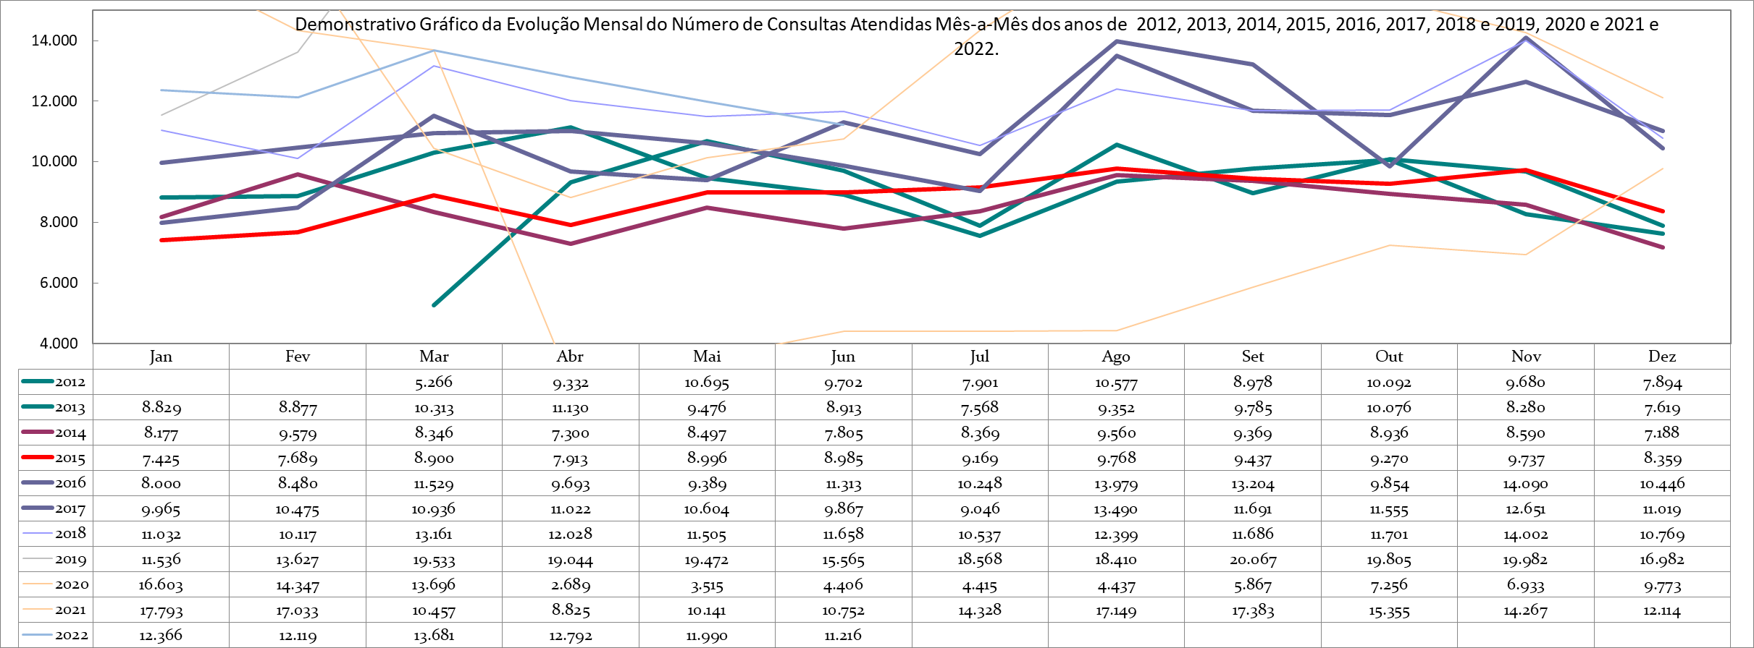

|  |  |  |  |  |  |  |  |  |  |  |  |
| --- | --- | --- | --- | --- | --- | --- | --- | --- | --- | --- | --- |
| **Produção Mensal de Atos Multidisciplinares** | | | | | | | | | | | |
|  | **2012** | **2013** | **2014** | **2015** | **2016** | **2017** | **2018** | **2019** | **2020** | **2021** | **2022** |
| **Jan** |  | 8.558 | 9.784 | 9.693 | 12.409 | 17.926 | 16.984 | 12.147 | 12.024 | 8.764 | 10.322 |
| **Fev** |  | 7.893 | 8.254 | 9.264 | 11.138 | 15.308 | 16.968 | 12.009 | 10.637 | 9.510 | 10.432 |
| **Mar** | 4.501 | 9.486 | 8.540 | 8.332 | 13.579 | 17.473 | 21.336 | 11.420 | 11.249 | 9.421 | 11.380 |
| **Abr** | 7.930 | 8.718 | 9.162 | 8.727 | 14.194 | 12.703 | 18.092 | 13.611 | 7.468 | 10.537 | 9.953 |
| **Mai** | 9.529 | 6.787 | 9.128 | 9.963 | 13.524 | 16.628 | 12.060 | 13.224 | 8.061 | 10.799 | 10.912 |
| **Jun** | 11.670 | 5.984 | 8.638 | 10.397 | 16.717 | 15.576 | 18.603 | 11.178 | 8.529 | 11.700 | 11.176 |
| **Jul** | 7.498 | 7.384 | 9.091 | 10.984 | 15.095 | 15.807 | 19.628 | 13.660 | 8.252 | 12.079 |  |
| **Ago** | 10.008 | 7.765 | 9.879 | 11.507 | 16.514 | 18.245 | 20.613 | 12.054 | 8.135 | 11.585 |  |
| **Set** | 7.823 | 7.046 | 12.383 | 11.243 | 16.386 | 16.873 | 17.459 | 11.949 | 8.261 | 10.891 |  |
| **Out** | 8.656 | 7.324 | 11.671 | 11.418 | 15.437 | 16.378 | 14.719 | 11.645 | 8.773 | 10.891 |  |
| **Nov** | 9.911 | 8.369 | 10.286 | 12.738 | 16.091 | 16.751 | 11.966 | 11.229 | 8.566 | 10.567 |  |
| **Dez** | 7.953 | 10.090 | 11.029 | 11.806 | 15.764 | 17.090 | 10.648 | 9.414 | 8.849 | 4.519 |  |
| **TOTAL** | **85.479** | **95.404** | **117.845** | **126.072** | **176.848** | **196.758** | **199.076** | **143.540** | **108.804** | **121.263** | **64.175** |
| **Média** | **8.548** | **7.950** | **9.820** | **10.506** | **14.737** | **16.397** | **16.590** | **11.962** | **9.067** | **10.105** | **10.696** |

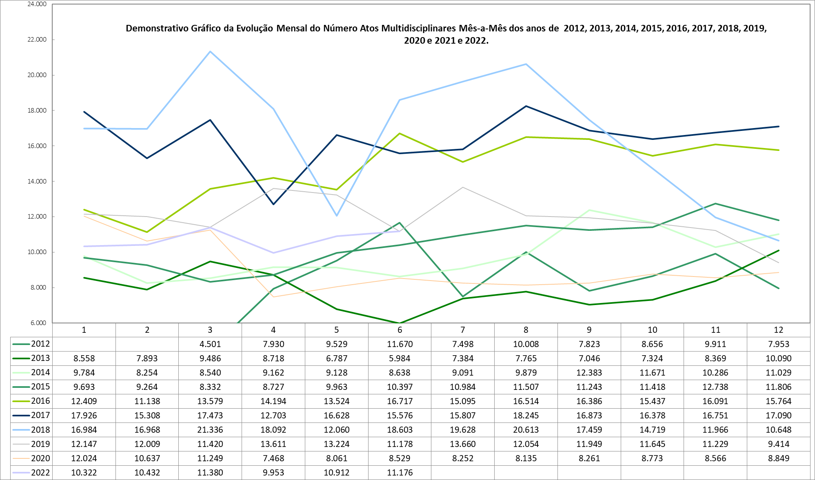

|  |  |  |  |  |  |  |  |  |  |  |  |
| --- | --- | --- | --- | --- | --- | --- | --- | --- | --- | --- | --- |
| **Produção Mensal de SADT** | | | | | | | | | | | |
|  | **2012** | **2013** | **2014** | **2015** | **2016** | **2017** | **2018** | **2019** | **2020** | **2021** | **2022** |
| **Jan** |  | 19.935 | 28.161 | 22.443 | 20.808 | 23.823 | 31.507 | 24.420 | 29.904 | 30.369 | 32.207 |
| **Fev** |  | 17.846 | 22.621 | 18.779 | 17.766 | 25.791 | 30.142 | 21.384 | 29.210 | 29.268 | 30.827 |
| **Mar** | 8.282 | 20.759 | 24.065 | 24.011 | 22.797 | 22.326 | 31.360 | 24.644 | 31.965 | 25.350 | 34.556 |
| **Abr** | 16.374 | 20.897 | 23.611 | 23.416 | 24.477 | 29.101 | 32.718 | 28.345 | 27.687 | 36.301 | 31.737 |
| **Mai** | 16.931 | 22.155 | 22.529 | 25.588 | 23.743 | 25.225 | 32.934 | 29.355 | 28.910 | 35.037 | 33.388 |
| **Jun** | 17.597 | 21.825 | 22.633 | 25.140 | 25.141 | 32.830 | 31.123 | 28.786 | 30.094 | 35.197 | 30.613 |
| **Jul** | 17.371 | 21.094 | 22.728 | 25.862 | 26.136 | 24.233 | 32.431 | 33.344 | 28.578 | 33.774 |  |
| **Ago** | 21.310 | 21.464 | 23.431 | 27.703 | 28.968 | 37.094 | 35.789 | 32.306 | 28.303 | 35.279 |  |
| **Set** | 20.114 | 18.985 | 21.426 | 23.321 | 27.506 | 28.027 | 32.441 | 33.266 | 27.619 | 32.166 |  |
| **Out** | 20.153 | 20.671 | 21.128 | 23.934 | 33.268 | 29.806 | 26.919 | 29.040 | 26.251 | 34.683 |  |
| **Nov** | 17.739 | 20.819 | 24.033 | 22.545 | 27.287 | 28.858 | 19.552 | 29.264 | 28.201 | 32.624 |  |
| **Dez** | 19.513 | 24.664 | 23.629 | 21.651 | 25.821 | 29.905 | 23.069 | 30.388 | 28.700 | 32.666 |  |
| **TOTAL** | **175.384** | **251.114** | **279.995** | **284.393** | **303.718** | **337.019** | **359.985** | **344.542** | **345.422** | **392.714** | **193.328** |
| **Média** | **18.461** | **20.926** | **23.333** | **23.699** | **25.310** | **28.085** | **29.999** | **28.712** | **28.785** | **32.726** | **32.221** |

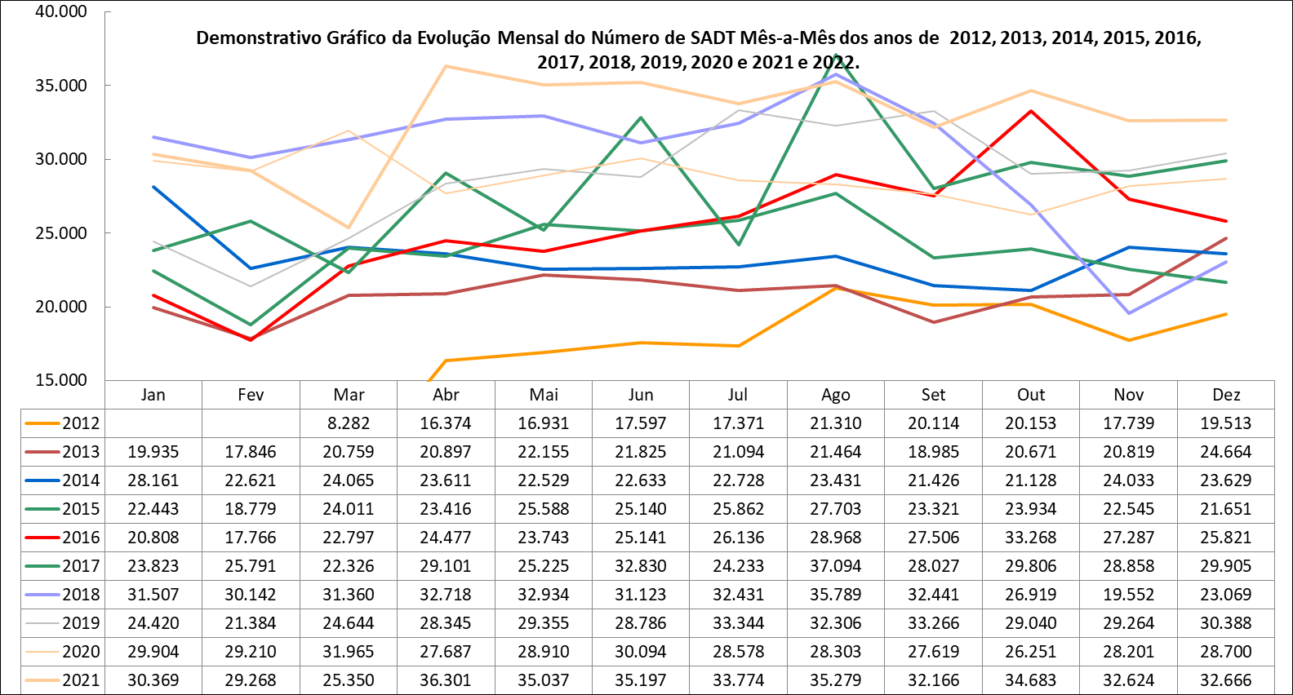

|  |  |  |  |  |  |  |  |  |  |  |  |
| --- | --- | --- | --- | --- | --- | --- | --- | --- | --- | --- | --- |
| **Produção Mensal de Cirurgias** | | | | | | | | | | | |
|  | **2012** | **2013** | **2014** | **2015** | **2016** | **2017** | **2018** | **2019** | **2020** | **2021** | **2022** |
| **Jan** |  | 348 | 302 | 276 | 415 | 454 | 520 | 573 | 595 | 550 | 344 |
| **Fev** |  | 308 | 305 | 280 | 356 | 438 | 478 | 597 | 518 | 659 | 390 |
| **Mar** | 184 | 412 | 323 | 436 | 488 | 521 | 546 | 598 | 550 | 418 | 689 |
| **Abr** | 328 | 466 | 328 | 413 | 422 | 468 | 564 | 707 | 242 | 316 | 546 |
| **Mai** | 357 | 355 | 322 | 498 | 428 | 590 | 634 | 718 | 300 | 355 | 618 |
| **Jun** | 353 | 367 | 298 | 490 | 470 | 526 | 576 | 582 | 296 | 422 | 548 |
| **Jul** | 383 | 410 | 311 | 537 | 426 | 507 | 651 | 736 | 282 | 518 |  |
| **Ago** | 450 | 420 | 329 | 539 | 562 | 555 | 663 | 811 | 285 | 625 |  |
| **Set** | 364 | 331 | 353 | 502 | 488 | 501 | 588 | 700 | 307 | 618 |  |
| **Out** | 420 | 338 | 390 | 489 | 416 | 505 | 563 | 705 | 329 | 578 |  |
| **Nov** | 389 | 311 | 379 | 482 | 481 | 526 | 505 | 653 | 411 | 544 |  |
| **Dez** | 303 | 250 | 340 | 325 | 439 | 476 | 437 | 511 | 425 | 462 |  |
| **TOTAL** | **3.531** | **4.316** | **3.980** | **5.267** | **5.391** | **6.067** | **6.725** | **7.891** | **4.540** | **6.065** | **3.135** |
| **Média** | **372** | **360** | **332** | **439** | **449** | **506** | **560** | **658** | **378** | **505** | **523** |

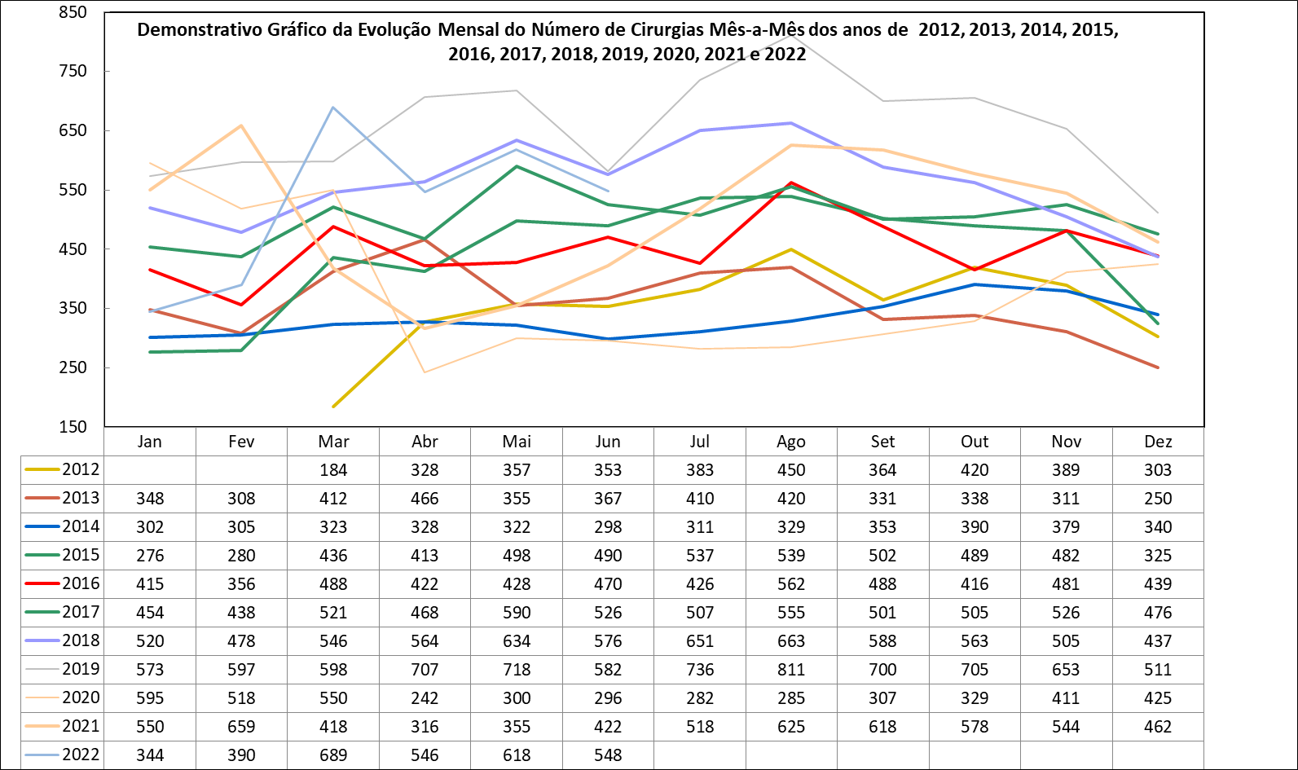

|  |  |  |  |  |  |  |  |  |  |  |  |
| --- | --- | --- | --- | --- | --- | --- | --- | --- | --- | --- | --- |
| **Produção Mensal de Internações** | | | | | | | | | | | |
|  | **2012** | **2013** | **2014** | **2015** | **2016** | **2017** | **2018** | **2019** | **2020** | **2021** | **2022** |
| **Jan** |  | 472 | 571 | 476 | 552 | 631 | 738 | 862 | 811 | 736 | 557 |
| **Fev** |  | 460 | 630 | 490 | 439 | 608 | 606 | 730 | 668 | 835 | 571 |
| **Mar** | 436 | 594 | 577 | 529 | 522 | 676 | 725 | 763 | 679 | 506 | 713 |
| **Abr** | 431 | 658 | 593 | 438 | 669 | 637 | 793 | 883 | 394 | 487 | 615 |
| **Mai** | 459 | 673 | 584 | 722 | 628 | 763 | 796 | 867 | 442 | 459 | 753 |
| **Jun** | 482 | 680 | 529 | 630 | 604 | 639 | 791 | 785 | 422 | 573 | 704 |
| **Jul** | 475 | 599 | 549 | 593 | 646 | 726 | 826 | 913 | 406 | 670 |  |
| **Ago** | 587 | 690 | 563 | 584 | 698 | 694 | 840 | 980 | 411 | 773 |  |
| **Set** | 517 | 572 | 582 | 580 | 646 | 692 | 758 | 864 | 401 | 751 |  |
| **Out** | 572 | 535 | 607 | 695 | 636 | 730 | 720 | 844 | 429 | 782 |  |
| **Nov** | 546 | 593 | 555 | 689 | 655 | 701 | 590 | 820 | 563 | 692 |  |
| **Dez** | 542 | 675 | 548 | 499 | 597 | 673 | 651 | 710 | 507 | 619 |  |
| **TOTAL** | **5.047** | **7.201** | **6.888** | **6.925** | **7.292** | **8.170** | **8.834** | **10.021** | **6.133** | **7.883** | **3.913** |
| **Média** | **505** | **600** | **574** | **577** | **608** | **681** | **736** | **835** | **511** | **657** | **652** |

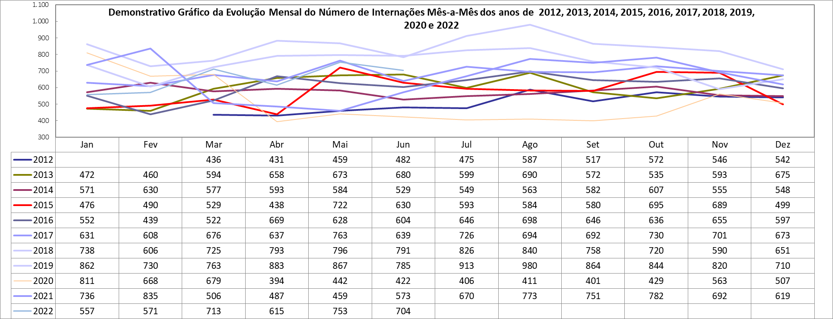

|  |  |  |  |  |  |  |  |
| --- | --- | --- | --- | --- | --- | --- | --- |
| **Produção Mensal de Saídas Hospitalares** | | | | | | | |
|  | **2016** | **2017** | **2018** | **2019** | **2020** | **2021** | **2022** |
| **Jan** |  | 553 | 670 | 819 | 765 | 711 | 543 |
| **Fev** |  | 632 | 593 | 689 | 686 | 796 | 571 |
| **Mar** | 515 | 652 | 766 | 782 | 702 | 519 | 739 |
| **Abr** | 566 | 651 | 788 | 863 | 384 | 469 | 616 |
| **Mai** | 534 | 697 | 771 | 867 | 450 | 477 | 743 |
| **Jun** | 581 | 671 | 763 | 782 | 403 | 558 | 714 |
| **Jul** | 633 | 698 | 797 | 892 | 431 | 698 |  |
| **Ago** | 683 | 676 | 823 | 981 | 399 | 761 |  |
| **Set** | 640 | 689 | 751 | 836 | 413 | 774 |  |
| **Out** | 622 | 672 | 704 | 838 | 467 | 774 |  |
| **Nov** | 620 | 691 | 586 | 852 | 518 | 810 |  |
| **Dez** | 654 | 728 | 698 | 732 | 564 | 660 |  |
| **TOTAL** | **6.048** | **8.010** | **8.710** | **9.933** | **6.182** | **8.007** | **3.926** |
| **Média** | **605** | **668** | **726** | **828** | **515** | **667** | **654** |

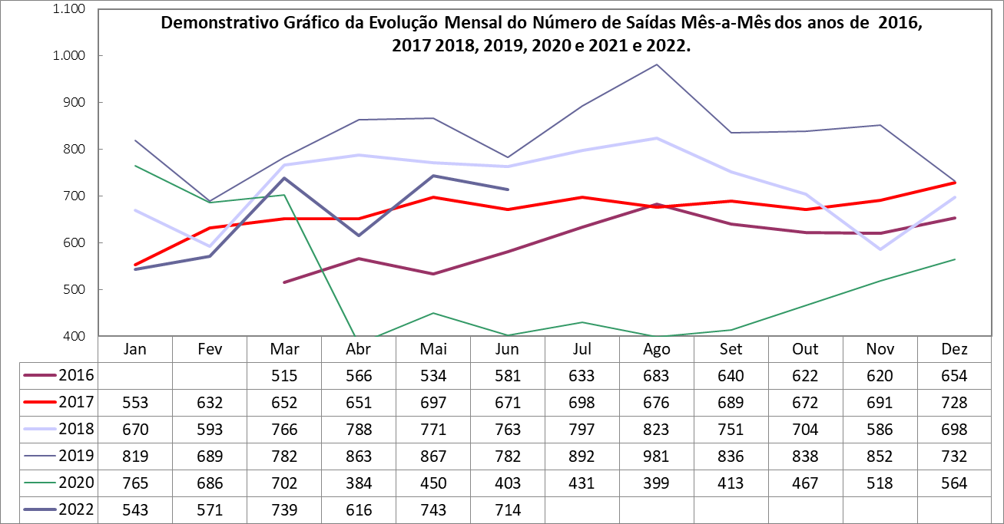

|  |  |  |  |  |  |
| --- | --- | --- | --- | --- | --- |
| **Produção Ambulatorial - CEAD** | | | | | |
|  | **2018** | **2019** | **2020** | **2021** | **2022** |
| **Jan** |  | 1.752 | 1.285 | 1.636 | 1.627 |
| **Fev** |  | 1.968 | 1.551 | 1.412 | 1.419 |
| **Mar** |  | 1.554 | 1.426 | 1.168 | 1.951 |
| **Abr** |  | 2.188 | 386 | 621 | 1.575 |
| **Mai** |  | 2.054 | 572 | 956 | 2.096 |
| **Jun** |  | 2.115 | 945 | 859 | 2.034 |
| **Jul** | 491 | 1.873 | 821 | 643 |  |
| **Ago** | 908 | 1.918 | 849 | 651 |  |
| **Set** | 1.161 | 1.706 | 837 | 1.144 |  |
| **Out** | 1.854 | 1.637 | 2.097 | 1.410 |  |
| **Nov** | 1.687 | 1.748 | 1.059 | 2.157 |  |
| **Dez** | 1.738 | 1.495 | 1.096 | 1.678 |  |
| **TOTAL** | **7.839** | **22.008** | **12.924** | **14.335** | **10.702** |
| **Média** | **1.307** | **1.834** | **1.077** | **1.195** | **1.784** |

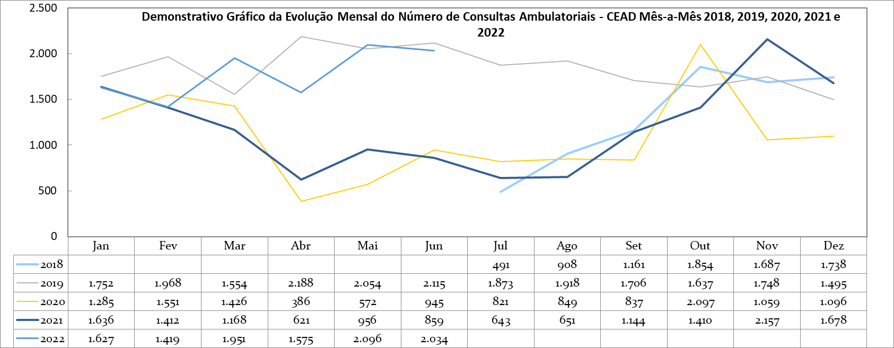

|  |  |  |  |  |  |  |
| --- | --- | --- | --- | --- | --- | --- |
| **Produção Mensal de Transplantes Renais** | | | | | | |
|  | **2017** | **2018** | **2019** | **2020** | **2021** | **2022** |
| **Jan** | 0 | 8 | 7 | 15 | 3 | 2 |
| **Fev** | 0 | 13 | 11 | 7 | 10 | 10 |
| **Mar** | 13 | 8 | 13 | 25 | 3 | 9 |
| **Abr** | 8 | 9 | 13 | 4 | 13 | 4 |
| **Mai** | 4 | 12 | 13 | 15 | 5 | 8 |
| **Jun** | 9 | 18 | 9 | 15 | 10 | 7 |
| **Jul** | 10 | 15 | 0 | 12 | 11 |  |
| **Ago** | 11 | 10 | 23 | 14 | 6 |  |
| **Set** | 6 | 10 | 17 | 9 | 6 |  |
| **Out** | 3 | 10 | 25 | 9 | 10 |  |
| **Nov** | 14 | 13 | 29 | 16 | 10 |  |
| **Dez** | 5 | 5 | 6 | 11 | 10 |  |
| **TOTAL** | **83** | **131** | **166** | **152** | **97** | **40** |
| **Média** | **7** | **11** | **14** | **13** | **8** | **7** |

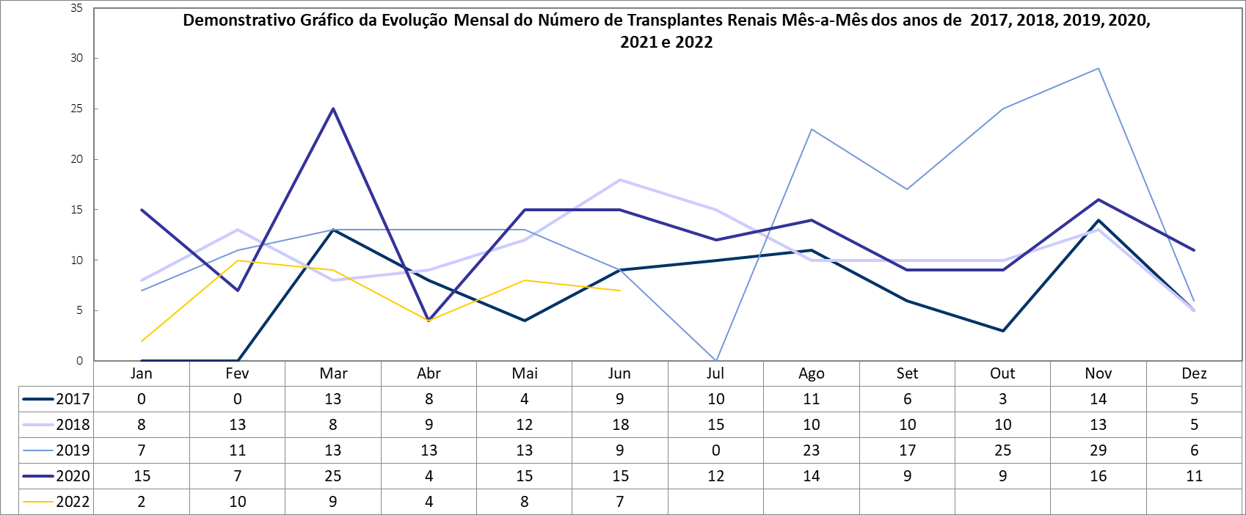

|  |  |  |  |  |  |
| --- | --- | --- | --- | --- | --- |
| **Produção Mensal de Transplantes Hepáticos** | | | | | |
|  | **2018** | **2019** | **2020** | **2021** | **2022** |
| **Jan** | 0 | 0 | 1 | 2 | 0 |
| **Fev** | 0 | 1 | 0 | 0 | 1 |
| **Mar** | 0 | 1 | 0 | 1 | 0 |
| **Abr** | 0 | 0 | 0 | 2 | 1 |
| **Mai** | 0 | 0 | 2 | 1 | 1 |
| **Jun** | 0 | 2 | 0 | 1 | 0 |
| **Jul** | 1 | 0 | 1 | 1 |  |
| **Ago** | 0 | 2 | 2 | 1 |  |
| **Set** | 0 | 0 | 1 | 1 |  |
| **Out** | 0 | 0 | 2 | 1 |  |
| **Nov** | 1 | 0 | 0 | 0 |  |
| **Dez** | 3 | 0 | 1 | 1 |  |
| **TOTAL** | **5** | **6** | **10** | **12** | **3** |
| **Média** | **0** | **1** | **1** | **1** | **1** |

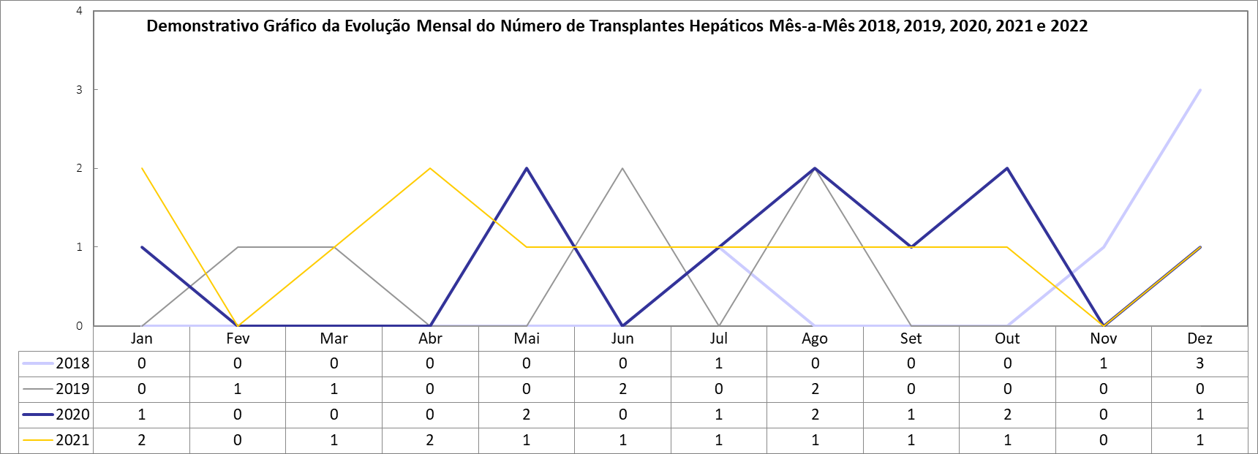

|  |  |  |  |  |  |  |  |  |  |  |  |  |
| --- | --- | --- | --- | --- | --- | --- | --- | --- | --- | --- | --- | --- |
| **Programas e Serviços Multidisciplinares** | | | | | | | | | | | | |
|  | **01/22** | | **02/22** | | **03/22** | | **04/22** | | **05/21** | | **06/21** | |
|  | **Número de Consultas** | **Número de Cirurgias** | **Número de Consultas** | **Número de Cirurgias** | **Número de Consultas** | **Número de Cirurgias** | **Número de Consultas** | **Número de Cirurgias** | **Número de Consultas** | **Número de Cirurgias** | **Número de Consultas** | **Número de Cirurgias** |
| **Projeto Transexualizador Hospitalar** | **144** | 2 | **152** | 2 | **185** | 6 | **125** | 3 | **130** | 2 | **204** | 2 |
| **Serviço de Atenção aos Pacientes Portadores de Hérnias Abdominais Complexas** | **24** | 2 | **21** | 6 | **19** | 7 | **22** | 6 | **24** | 6 | **28** | 7 |
| **Serviço de Transplantes Renais** | **389** | 2 | **459** | 10 | **497** | 9 | **373** | 4 | **487** | 8 | **479** | 7 |
| **Serviço de Atenção Ambulatorial Hospitalar Portadores de Doenças Raras** | **17** | 0 | **21** | 0 | **10** | 0 | **14** | 0 | **8** | 0 | **18** | 0 |
| **Serviço Ambulatorial em Reabilitação Cardíaca** | **131** | 0 | **372** | 0 | **504** | 0 | **289** | 0 | **382** | 0 | **381** | 0 |
| **Atendimento do PCCO** | **519** | 1 | **409** | 3 | **690** | 4 | **513** | 9 | **851** | 2 | **851** | 4 |
| **Atendimento de Cirúrgias Metabólicas** | **108** | 3 | **108** | 1 | **89** | 4 | **858** | 5 | **102** | 2 | **90** | 3 |
| **NOIS** | **116** | 0 | **185** | 0 | **188** | 0 | **100** | 0 | **216** | 0 | **255** | 0 |
| **Programa Pé diabético** | **143** | 0 | **103** | 0 | **271** | 0 | **119** | 0 | **206** | 0 | **125** | 0 |
| **Serviço de Transplantes Hepáticos** | **29** | 0 | **23** | 1 | **30** | 0 | **25** | 1 | **24** | 1 | **24** | 0 |

